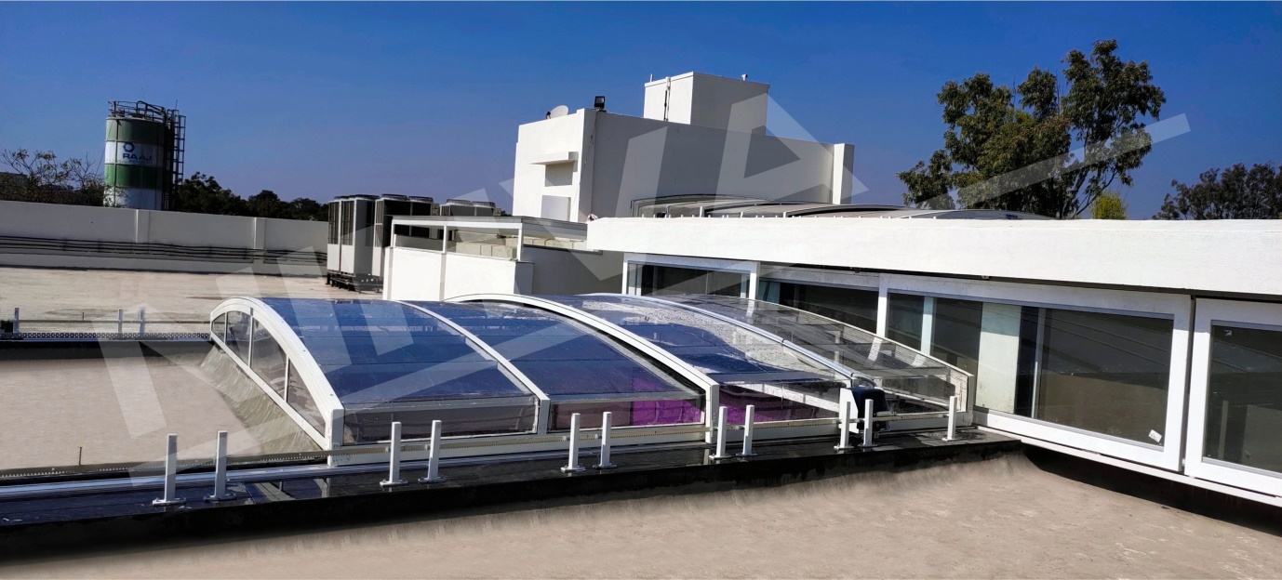
Connect to nature instantly!
Our innovative Retractable roof lets you connect to the nature instantly with a click of a button.
Enjoy the fresh air and sunlight whenever you feel, get the best experience.
The light weight frame makes the operation smooth with one touch. We make possible!

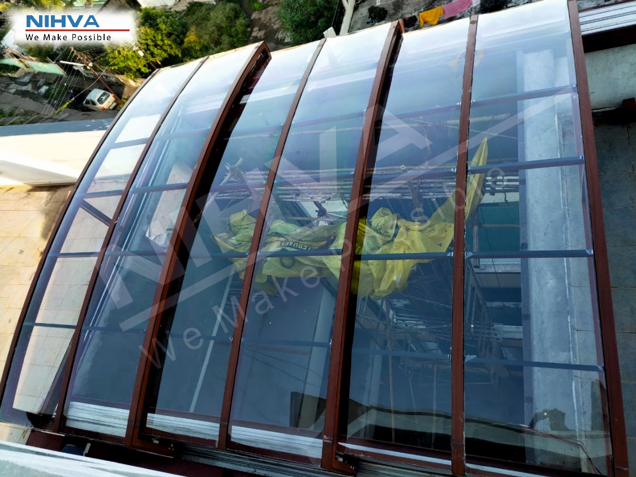
Experience the Best.
Our revolutionary Design allows for unparalleled coverage, ease of deployment and unrelenting protection from both the sun and rain.

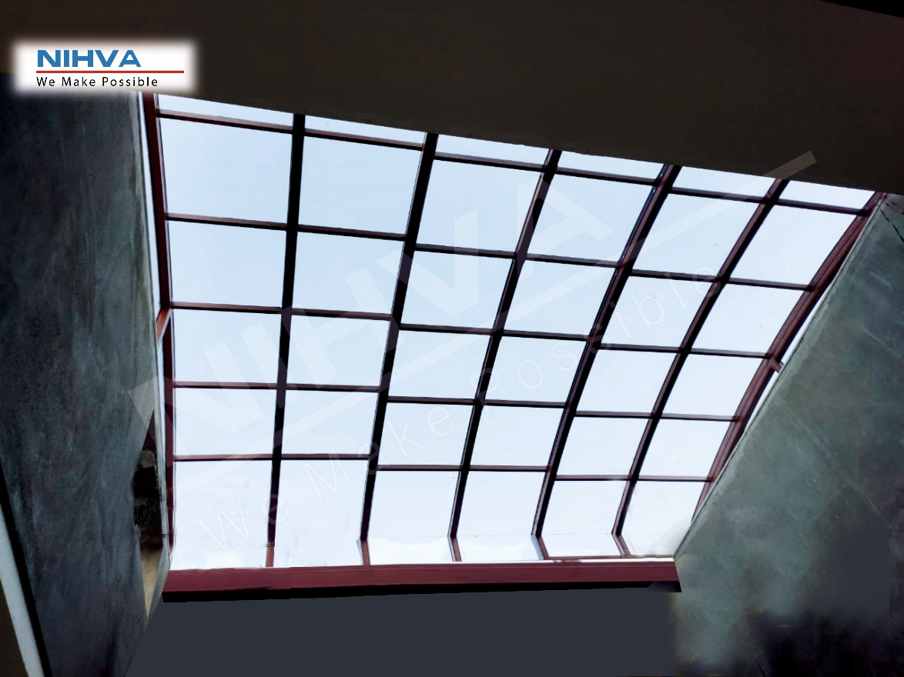
Mounts above. Clears Everything Below.

Look at the sky full of stars from the roof of your home. Yes, it is possible with our innovation.
Specially designed retractable roofing system helps you resonate with the nature whenever you wish.
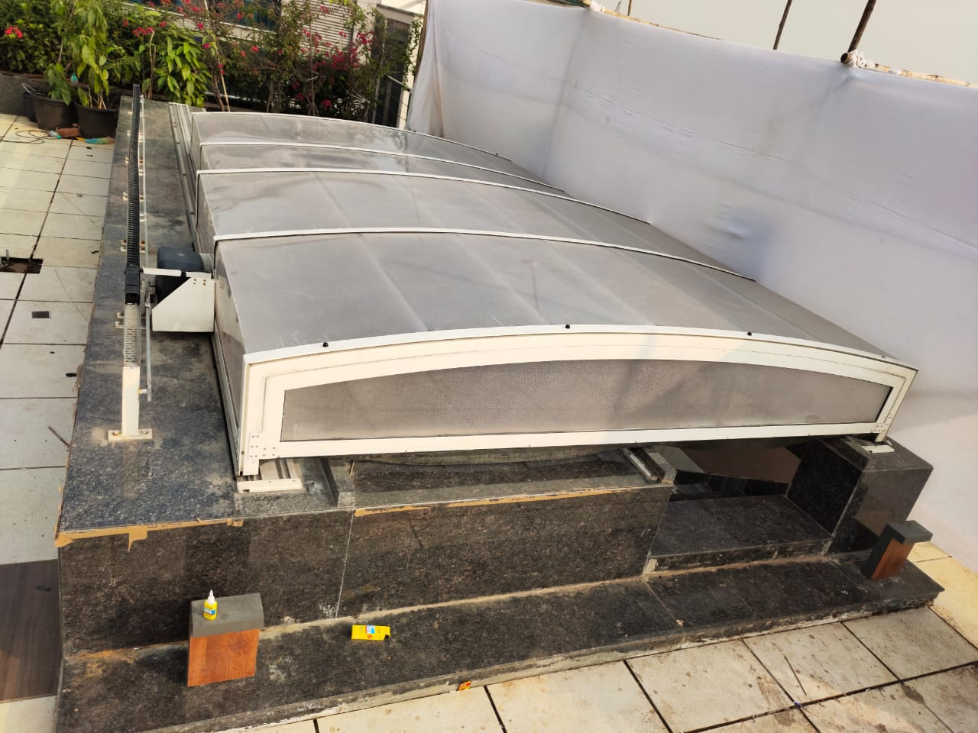
Best roofing solution!.
Our innovative solution facilitates even the most eclectic designs and tastes while setting the new industry standard in outdoor space utility. Our track technology ensures that your roof will extend and retract smoothly with no jamming or binding of its movement. The roof can be stopped at any desired position from “fully extended” to “fully retract”.

